Tejaswini SE

1RVU22BSC105

**Lab Activity 1 – Registration Form**

1.Basic html and styling are used in the code.

2. The form includes username, password, email, phone number, fields interested and age.

3. The page uses simple CSS to style.

4. The validation checks if the username and fields interested contain only letters.

5.If they contain any numbers or special characters, an error message is added.

6.Username and fields interested should only contain letters.

7.Phone number should contain exactly 10 digits.

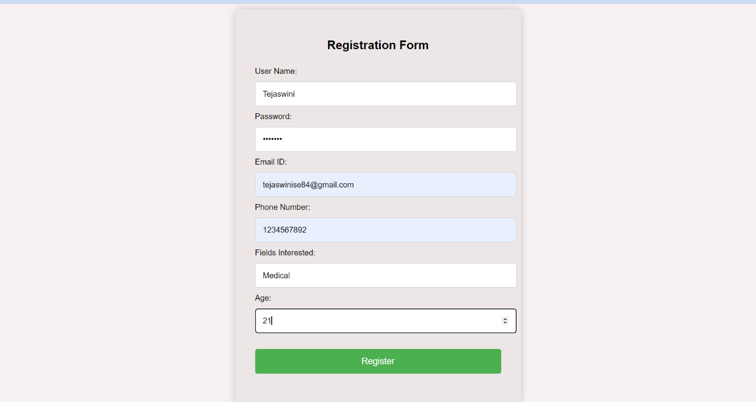

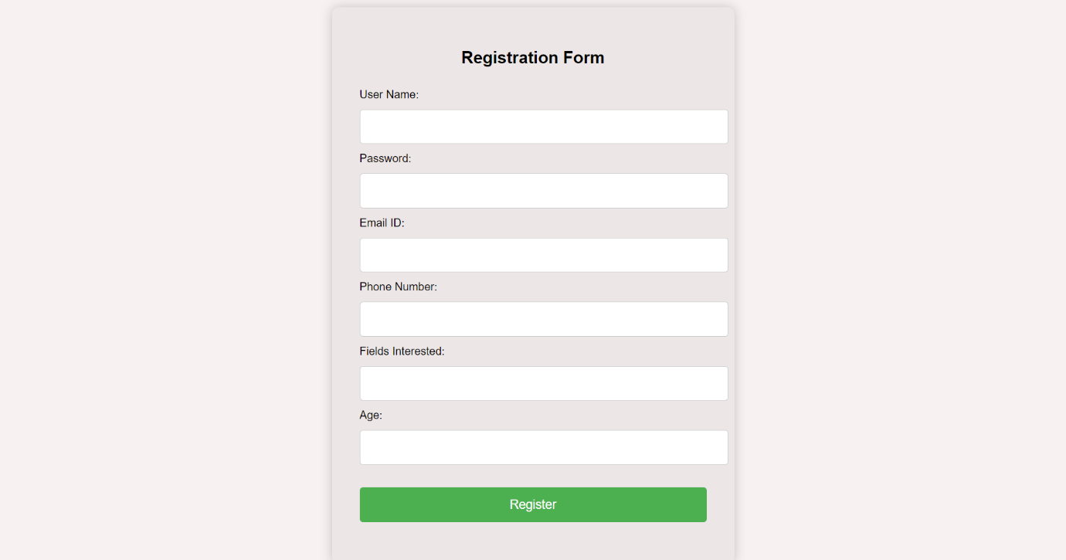

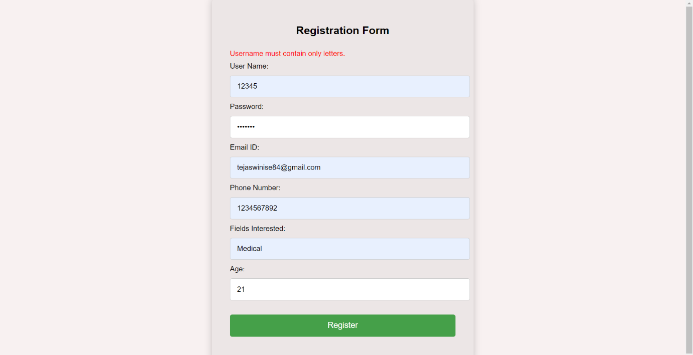

**Code:** 